Facts for the trade press for the AMB 2024 exhibition
zur AMB 2024
Refining surfaces with the mass finishing technology

Walther Trowal:
Gentle surface finishing of metal components
Haan,Germany, July 15, 2024. At the AMB 2024 exhibition Walther Trowal displays its equipment to demonstrate the versatility of the mass finishing technology for finishing the surface of high-value components. The company also displays a Rotamat system for eco-friendly coating of mass- produced small parts with PFAS-free lacquers.
For grinding, deburring and edge radiusing of metal components Walther Trowal displays a centrifugal disk finishing machine, type TT---A/2C. Due to the fact that it practically eliminates non-productive idle machine times, this finishing system offers a particularly high productivity with a high work piece throughput and requires a surprisingly small footprint. The so-called “double batch” principle allows processing -- like deburring, edge radiusing or surface smoothing -- of one work piece batch, while a second batch is passing through the separation system.
The company also presents its CB rotary vibrators, which can be easily integrated into interlinked manufacturing operations. Optional technical characteristics like the work piece infeed chute on the outside of the processing channel and the gate clearing feature greatly facilitate the integration of these machines into automated production processes.
Walther Trowal also displays the Rotamat R 60 system for decorative or functional coating of mass-produced small metal parts. This innovative machine allows the use of eco-friendly PFAS-free lacquers, which are increasingly employed by the customers. Numerous functional coating materials still contain hazardous materials like polytetrafluorethylene (PTFE) and solvents, which, for environmental reasons, must be replaced by less dangerous substances. Even though their use is not yet prohibited, the pressure to eliminate these hazardous materials is increasing. With its redesigned Rotamat system Walther Trowal now offers manufacturers of metal parts and coating job shops a system that allows the quick and problem-free transformation to PFAS-free lacquers.
Walther Trowal at the AMB 2024:
September 10 – 14, 2024 in Stuttgart, Germany
Hall 5, Booth 5B48
Contact:  Walther Trowal GmbH & Co. KG  Georg Harnau  Rheinische Str. 35-37  42781 Haan, Germany  Tel: +49 2129 571-209  www.walther-trowal.de  g.harnau@walther-trowal.de | Contact the editor:  VIP Kommunikation  Dr.-Ing. Uwe Stein  Dennewartstraße 25-27  52068 Aachen, Germany  Tel: +49 241 89468-55  www.vip-kommunikation.de  stein@vip-kommunikation.de
Photos
Download of high-resolution photos: Pressefotos Walther Trowal
Photo 1: A production line with rotary vibrators, model CB 300 File name:  WT-CB-Verkettet-SKF-4.jpg | 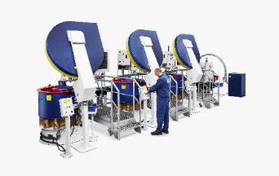
Photo 2: A Turbotron (TT) centrifugal disk finishing system in double batch version  File name:  Walther-Trowal-TT_A_2_C-(8).jpg | 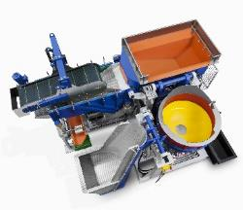
Photo 3: At the exit of their processing channel rotary vibrators are equipped with an integrated separation screen that allows the separation of the finished work pieces from the processing media.  File name:  WT_Schleifmittel_AF-0621-4673.jpg | 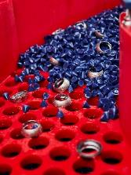
Abb. 4: The new Rotamat R 100 coater can handle work pieces with a diameter of up to 300 mm.  File name:  Walther-Trowal-R 100-3079.jpg | 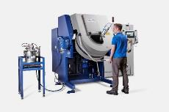
Copyright photos: Walther Trowal

About Walther Trowal
Surface finishing technologies from the inventor of the “Trowalizing” process
Since 1931 Walther Trowal has been developing and producing systems for the refinement of surfaces. Initially focusing exclusively on mass finishing – the term “Trowalizing” originated from the company’s cable address “Trommel Walther” – Walther Trowal has continuously expanded its product portfolio.
Over time the company has developed a broad range of machinery and systems for mass finishing, shot blasting and coating of mass-produced small components.
With the invention of new systems like, for example, drag finishing and the development of special finishing methods for 3D printed components, the company has proven its innovative capabilities again and again.
Walther Trowal develops and implements complete surface treatment solutions that can be seamlessly integrated into linked production systems existing at the customers. This includes the entire process technology, perfectly adapted to the specific surface finishing requirements of the work pieces: Equipment and the respective consumables always complement each other in a perfect manner.
Each individual work piece and each manufacturing process must meet special technical requirements. That is why the experienced process engineers in our test lab, in close cooperation with the customers, develop the optimal process technology for the finishing task at hand. The result: Work piece surfaces that meet exactly the required specifications…with short processing times and a high degree of consistent, repeatable results.
Walther Trowal is one of the few manufacturers who develops and produces all machines and mass finishing consumables in-house… including ceramic and plastic grinding and polishing media as well as compounds.
The company’s equipment range also includes all kinds of peripheral equipment for handling the work pieces like lift and tip loaders, conveyor belts and roller conveyors, in addition, special driers for mass finishing applications and, last-but-not-least, systems for cleaning and recycling of the process water.
With its exchange program for wear items like work bowls, which are part of a continuous recycling program, Walther Trowal conserves valuable resources and, thus, makes a significant contribution towards sustainability in the field of industrial production. Quick technical support and the global repair and maintenance service ensure high uptimes for our equipment.
Walther Trowal serves customers in a wide range of different industries all over the world, for example, automotive, aerospace, medical engineering and wind power.

